VIDEO COAXIAL INTERNAL CABLE

- PARTS:

QUANTITY: PART #: NOMENCLATURE: LENGTH:

1 PER MACHINE 17357- CONNECTOR, 15-PIN, D-SUB N/A

1 PER MACHINE 17388- SHELL, CONNECTOR, 15-PIN N/A

1 PER MACHINE 19275- CABLE, COAX 120 INCHES

1 PER MACHINE 17648- CONNECTOR, BNC, 75Ω, 27 AWG N/A

- BNC ASSEMBLY:

A. SLIDE THE CONNECTOR CRIMP TUBES ONTO THE CO-AXIAL CABLE.

- STRIP ¾” OF THE OUTER INSULATION FROM THE CABLE ENDS.

- TRIM THE EXCESS SHIELDING FROM THE CABLE.

- STRIP 5/16” OF THE INNER INSULATION FROM THE CABLE ENDS.

- PLACE THE BARE ENDS OF THE CABLE IN A VISE.

- COAT THE BARE CONDUCTORS WIH FLUX, AND TIN THEM.

- INSERT THE BARE CONDUCTOR,WHILE HEATING IT, INTO THE CONNECTOR PIN.

- REMOVE THE SOLDERING IRON FROM THE CONDUCTOR/PIN.

NOTE 1
TEST THE CONNECTION BY PULLING ON IT. IF THE PIN PULLS OFF OF THE CONDUCTOR, REDO STEPS 2F THROUGH 2H UNTIL IT PASSES THE PULL TEST.

- INSERT THE PIN/CABLE ASSEMBLY INTO THE BNC COVER.

- THE ASSEMBLY SHOULD CONNECT ACCORDING TO DIAGRAM 1.

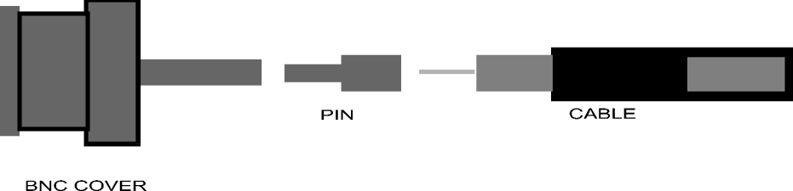

DIAGRAM 1

- 15-PIN ASSEMBLY:

- SLIDE THE CONNECTOR SHELL OVER THE COAX CABLE.

- STRIP ¾-INCH FROM THE OUTER INSULATION OF THE CABLE.

- TWIST THE SHIELDING INTO A SINGLE WIRE.

- SLIDE A 5/8-INCH LONG PIECE OF 1/8-INCH SHRINK TUBING OVER THE SHIELD WIRE, UP TO THE OUTER INSULATION.

- SHORT THE LOWER SEVEN PINS OF THE 15-PIN CONNECTOR, ACCORDING TO DIAGRAM 2.

- SOLDER THE SHIELD WIRE TO THE SHORTED PINS, ACCORDING TO DIAGRAM 2.

- SOLDER THE SIGNAL WIRE TO PIN #6 OF THE 15-PIN CONNECTOR.
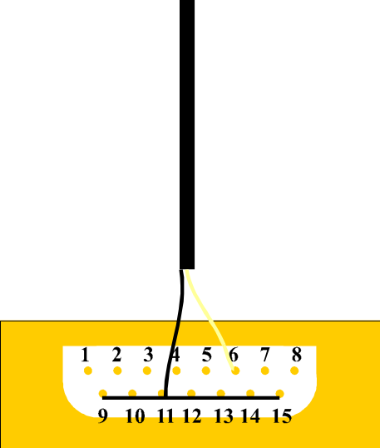

DIAGRRAM 2

H. ASSEMBLE THE SHELL OVER THE CONNECTOR.

